Projekt IEL

Vojtěch Hájek

xhajek51

Příklad 1

Stanovte napětí UR6 a proud IR6. Použijte metodu postupného zjednodušování obvodu.

|  |  |  |  |  |  |  |  |  |  |  |
| --- | --- | --- | --- | --- | --- | --- | --- | --- | --- | --- |
| sk. | U1 [V] | U2 [V] | R1 [Ω] | R2 [Ω] | R3 [Ω] | R4 [Ω] | R5 [Ω] | R6 [Ω] | R7 [Ω] | R8 [Ω] |
| G | 130 | 60 | 380 | 420 | 330 | 440 | 450 | 650 | 410 | 275 |

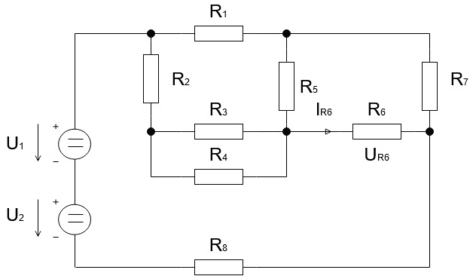

R34 = = 330 * + 440 = 188.5714 Ω

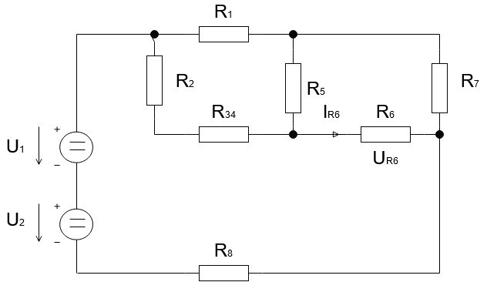

R234 = R2 + R34 = 420 + 188.5714 = 608.5714 Ω

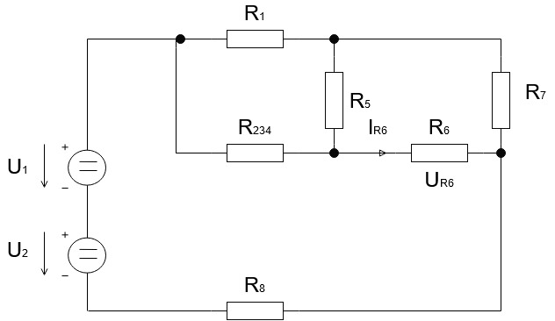

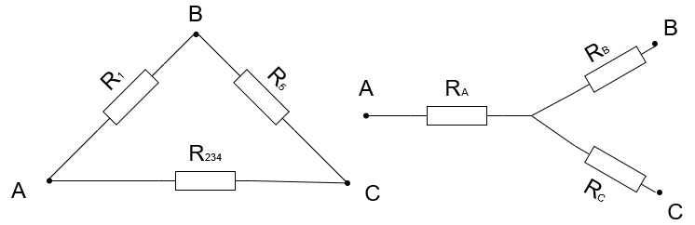

RA = = 380 * 608.5714 / 380 + 450 + 608.5714 = 160.7547 Ω

RB = = 380 * 450 / 380 + 450 + 608.5714 = 118.8679 Ω

RC = = 450 * 608.5714 / 380 + 450 + 608.5714 = 190.3674 Ω

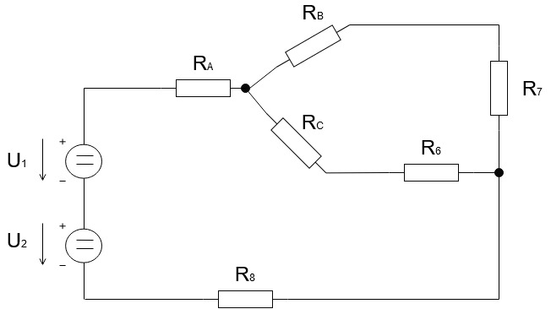

RB7 = RB + R7 = 118.8679 + 410 = 528.8679 Ω

RC6 = RC + R6 = 190.3674 + 650 = 840.3674 Ω

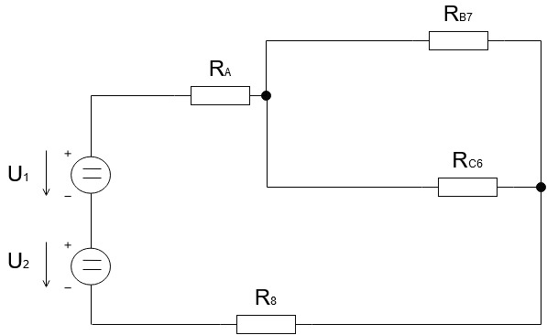

RB7C6 = = 528.8679 * 840.3674 / 528.8679 + 840.3674 = 324.5923 Ω

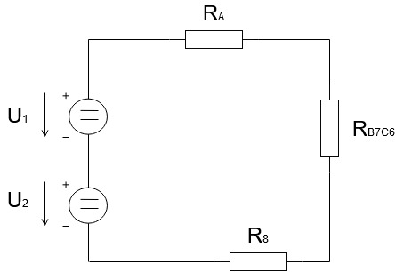

REKV = RA + RBC76 + R8 = 160.7547 + 324.5923 + 275 = 760.3471 Ω

U = U1 + U2 = 130 + 60 = 190 V

I = $\frac{U}{REKV}$ = 190 / 760.3471 = 0.2498 A

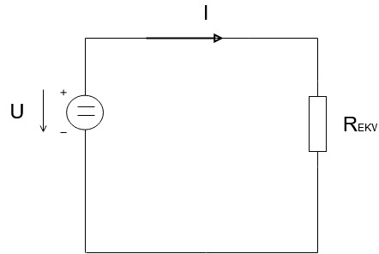

URA = RA * I = 160.7547 * 0.2498 = 40.1703 V

UR8 = R8 * I = 275 * 0.2498 = 68.7186 V

URB7C6 = RB7C6 * I = 324.5923 * 0.2498 = 81.1110 V

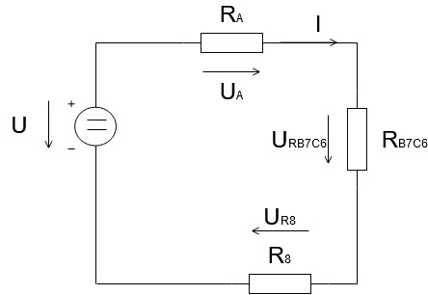

IRB7 = = 81.1110 / 528.8679 = 0.1533 A

IRC6 = = 81.1110 / 840.3674 = 0.0965 A

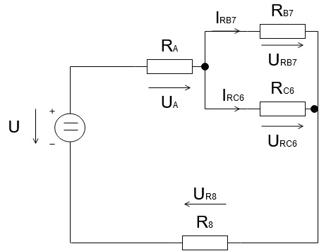

**UR6 = R6 * IRC6 = 650 * 0.0965 = 62.7370 V**

**IR6 = IRC6 = 0.0965 A**

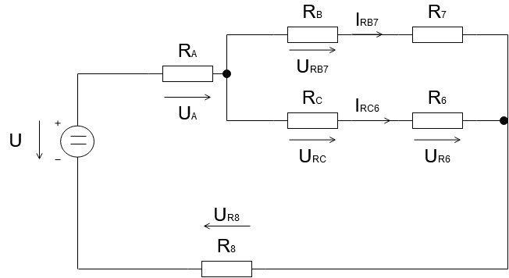

Příklad 2

Stanovte napětí UR3 a proud IR3. Použijte metodu Théveninovy věty.

|  |  |  |  |  |  |  |  |
| --- | --- | --- | --- | --- | --- | --- | --- |
| sk. | U [V] | R1 [Ω] | R2 [Ω] | R3 [Ω] | R4 [Ω] | R5 [Ω] | R6 [Ω] |
| H | 220 | 190 | 360 | 580 | 205 | 560 | 180 |

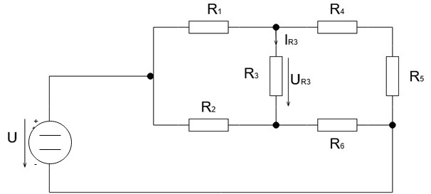

Obvod bez R3

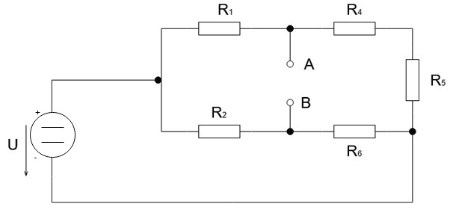

Zkratujeme napěťové zdroje

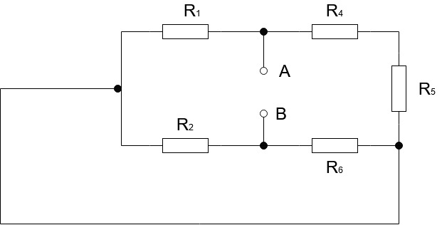

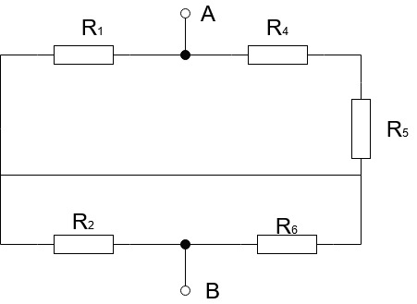

¨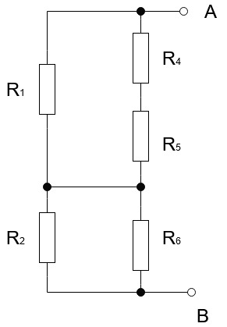

R45 = R4 + R5 = 205 + 560 = 765 Ω

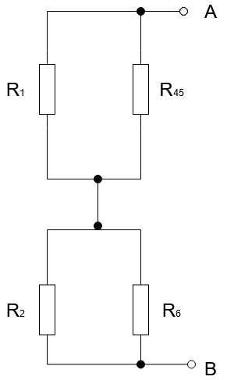

R145 = = 190 * 765 / 190 + 765 = 152.1989 Ω

R26 = = 360 * 160 / 360 + 160 = 110.7692 Ω

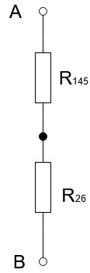

Ri= R145 + R26 = 152.1989 + 110.7692 = 262.9681 Ω

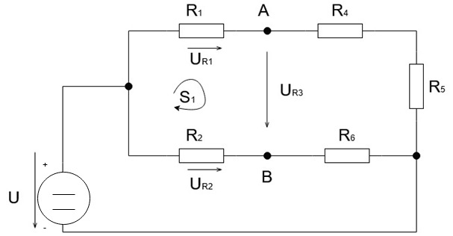

UR1 = U * ($\frac{R1}{R1 + R4 + R5}$) = 220 * (190/ 190 + 205 + 560) = 43.7696 V

UR2 = U * ($\frac{R2}{R2+R6}$) = 220 * (360 / 360 + 180) = 146.6666 V

S1:

UR1 + UR3 – UR2 = 0

**UR3** = UR2 – UR1 = 146.6666 - 43.7696 = **102.8970 V**

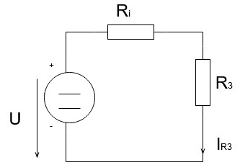

**IR3** = = 102.8970 / 262.9681 + 580 = **0.1220 A**

Příklad 3

Stanovte napětí UR2 a proud IR2. Použijte metodu uzlových napětí (UA, UB, UC).

|  |  |  |  |  |  |  |  |  |
| --- | --- | --- | --- | --- | --- | --- | --- | --- |
| sk. | U [V] | I1 [A] | I2 [A] | R1 [Ω] | R2 [Ω] | R3 [Ω] | R4 [Ω] | R5 [5] |
| C | 110 | 0.85 | 0.75 | 44 | 31 | 56 | 20 | 30 |

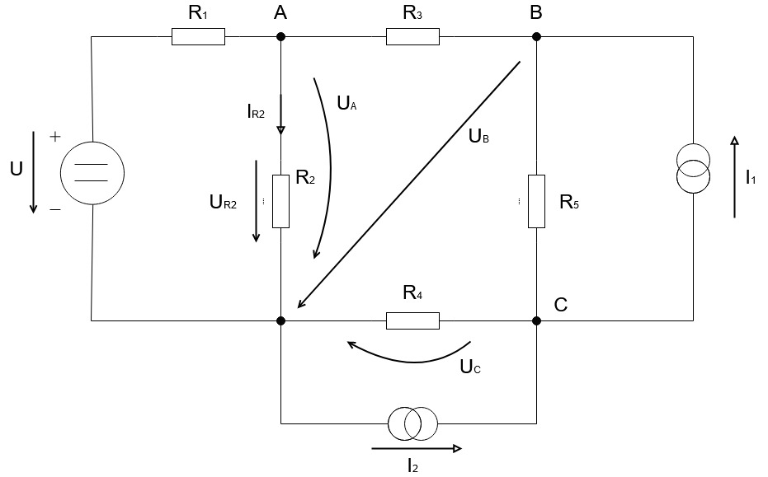

Uzel

A: IR1 – IR3 – IR2 = 0

B: IR3 + I1 – IR5 = 0

C: I2 – I1 + IR5 – IR4 = 0

Ohmův zákon

IR1 = $\frac{U – UA}{R1}$

IR2 = $\frac{UA}{R2}$

IR3 = $\frac{ UA- UB}{R3}$

IR4 = $\frac{UC}{R4}$

IR5 = $\frac{UB- UC}{R5}$

I.KZ

$\frac{U-UA}{R1}$– $\frac{UA-UB}{R3}$– $\frac{UA}{R2}$ = 0

+ 0.85 – $\frac{UB-UC}{R5}$ = 0

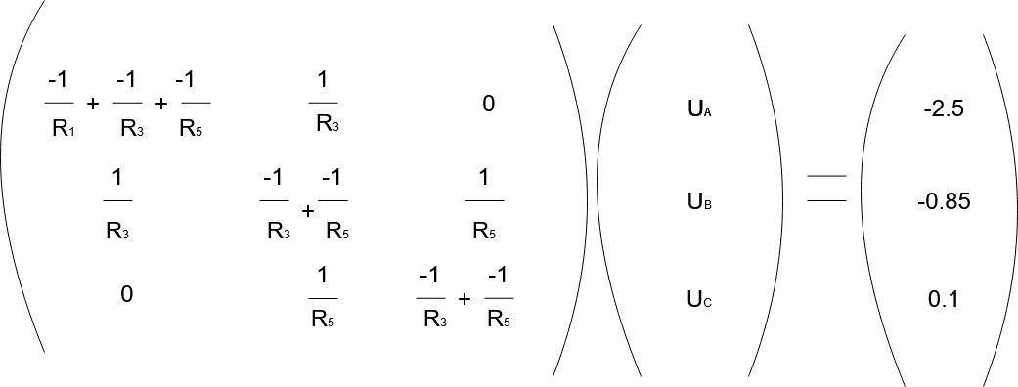(0.75 – 0.85) + $\frac{UB-UC}{R5}$– $\frac{UC}{R4}$ = 0

UA = 44.7393 V

UB = 42.4997 V

UC = 15.7999 V

IR1 = = 1.4832 A

IR2 = = 1.4432 A

**IR3** = = **0.0399 A**

IR4 = = 0.7899 A

IR5 = = 0.8899 A

Zkouška:

A: 1.4832 - 0.0399 - 1.4432 = 0

B: 0.0399 + 0.85 - 0.8899 = 0

C: 0.75 – 0.85 + 0.8899 - 0.7899 = 0

**UR3** = UA = **44.7393 V**

Příklad 4

Pro napájecí napětí platí: u1 = U1·sin(2πf t), u2 = U2·sin(2πf t).

Ve vztahu pro napětí uL2 = UL2 ·sin(2πf t + ϕL2 ) určete |UL2 | a ϕL2 . Použijte metodu smyčkových proudů.

Pozn: Pomocné směry šipek napájecích zdrojů platí pro speciální časový okamžik (t = π / 2ω).

|  |  |  |  |  |  |  |  |  |  |
| --- | --- | --- | --- | --- | --- | --- | --- | --- | --- |
| sk. | U1 [V] | U2 [V] | R1 [Ω] | R2 [Ω] | L1 [mH] | L2 [mH] | C1 [µF] | C2 [µF] | f [Hz] |
| G | 55 | 50 | 13 | 12 | 140 | 60 | 160 | 80 | 60 |

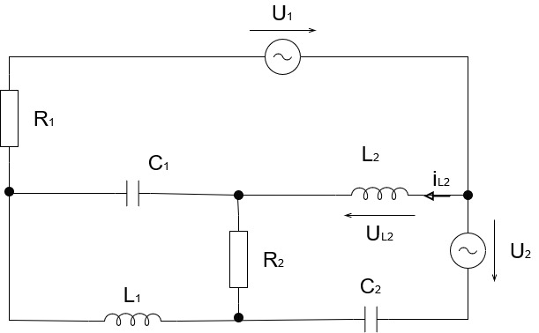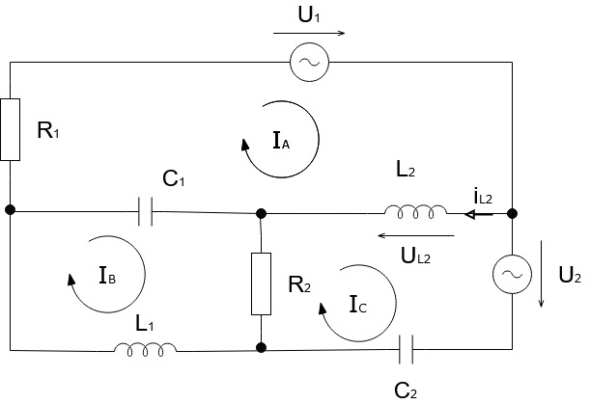

ω = 2πf = 376.98 [rad/s]

ZL1 = j * ω * L1 = j * 52.7772

ZL2 = j * ω * L2 = j * 22.6188

ZC1 = -j * = -j * 1.6579

ZC2 = -j * = -j * 3.3158

IA: R1 * IA + ZL2 * (IA – IC) + ZC1 * (IA – IB) + U1 = 0

IB: ZC1 * (IB – IA) + R2 * (IB – IC) + ZL1 * IB = 0

IC: ZL2 * (IC – IA) + ZC2 * IC + R2 * (IC – IB) + U2 = 0

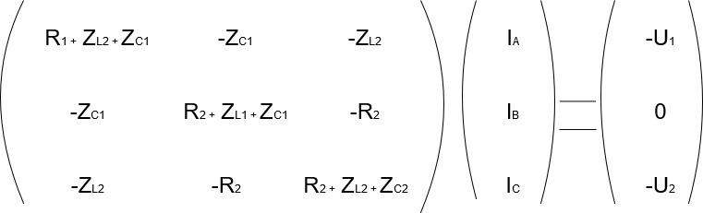

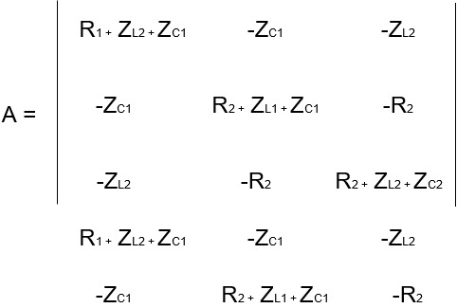

|A| = ((13+20,9609j)*( 12+20,9609j) * (12+19,303j))+((1,6579j)*(-12)*(- 22,6188j))+   
((-22,6188j)* (1,6579j)*(-12))-((-22,6188j)*(12+20,9609j)*(-22,6188j))-((-12)*12* (13+20,9609j))-((12+19,303j)* (1,6579j)*(1,6579j))

|A| = -6371,2063+14613,8197j

|IA| = ((-55)*( 12+20,9609j)*(12+19,303j))+(0*(-12)*(-22,6188j))+((-50)*( 1,6579j)*(-12))-   
((-22,6188j)*( 12+20,9609j)*(-50))-((-12)*(-12)*(-55))-((12+19,303j)*(1,6579j)*0)

|IA|= 45958,9741-39150,714j

IA = = -3,4032-1,6611j A

|IB| = ((13+20,9609j)*0*( 12+19,303j)) + ((1,6579j)*(-50)*(-22,6188j))+((-22,6188j)*(-55)*(-12))-((-22,6188j)*0*(-22,6188j))-((-12)*(-50)*(13+20,9609j))-((12+19,303j)*(-55)*(1,6579j))

|IB|= -11435,1198-26410,734j

IB = = -1,2319+1,3195j A

|IC| = ((13+20,9609j)*(12+20,9609j)*(-50))+((1,6579j)*(-12)*(-55))+((22,6188j)*(1,6579j)* 0)-((-55)*( 12+20,9609j)*(-22,6188j))-(0*(-12)*(13+20,9609j))-((-50)*(1,6579j)*(1,6579j))

|IC| = 40106,6070-40035,319j

IC = = -3,3074-1,3024j A

IL2 = IA – IC = (-3,4032-1,6611j) - (-3,3074-1,3024j) = -0,0958-0,3587j A

UL2 = IL2 * ZL2 = (-0,0958-0,3587j) * (22,6188j) = 8,1133-2,1668j V

|UL2|, ϕL2

**|UL2|** = √((8,1133)2-(2,1668j)2) = **8,3976**

ϕ= tan-1 = 14,95°

**UL2** = **8,3976 ∠ 14,95°**

Příklad 5

V obvodu na obrázku níže v čase t = 0 [s] sepne spínače S. Sestavte diferenciální rovnici popisující chování obvodu na obrázku, dále ji upravte dosazením hodnot parametrů. Vypočítejte analytické řešení iL = f (t). Proveďte kontrolu výpočtu dosazením do sestavené diferenciální rovnice.

|  |  |  |  |  |
| --- | --- | --- | --- | --- |
| sk. | U [V] | L [H] | R [Ω] | iL (0) [A] |
| H | 18 | 50 | 40 | 5 |

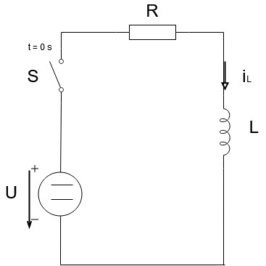

1. iL =
2. uR + uL – U = 0
3. iL‘ = , iL(0) = iLP

L * iL‘ + R * iL = U

**Očekáváné řešení:**

iL (t) = K(t) * eλt

**λ..?**

Lλ + R = 0 -> λ = - $\frac{R}{L}$

iL(t) = K(t) *e- t

iL(t) = K´(t) * e- t + K(t) * (- $\frac{R}{L}$) * e- t

dosazení rovnice

L * (K´(t) * e- t + K(t) * (- $\frac{R}{L}$) * e- t ) + R * K(t) *e- t = U

L * K´(t) * e- t - L * K(t) * ( $\frac{R}{L}$) * e- t + R * K(t) * e- t = U

L * K´(t) * e- t – R * K(t) * e- t + R * K(t) e- t = U

L * K´(t) * e- t = U

K´(t) = $\frac{U}{L}$* e t

K(t) = $\frac{\frac{U}{L}}{\frac{R}{L}}$* e t + k

K(t) = $\frac{U}{R}$* e t + k

Dosazení rovnice

iL = K(t) * e- t

iL = ( $\frac{U}{R}$* e t + k) * e- t

iL = $\frac{U}{R}$ + k * e- t

určení integrační konstanty z počáteční podmínky

iL(0)=iLP t=0s

iLP = + k * e0

k = iLP –

Analytické řešení

iL = f(t)

**iL** = **+ (iLP – ) * e- t**

zkouška:

iL = + (iLP – ) * e- t

5 = + (5 – ) * e0

5 = 5

iL(0) = iLP

**TABULKA VÝSLEDKŮ**

|  |  |  |
| --- | --- | --- |
| ÚLOHA | VARIANTA | VÝSLEDKY |
| 1. | G | UR6 = 62.7370 V IR6 = 0.0965 A |
| 2. | H | UR3 = 102.8970 V IR3 = 0.1220 A |
| 3. | C | UR3 = 44.7393 V IR2 = 0.0399 A |
| 4. | G | |UL2|= 8,3976 ϕ=14,95° UL2 = 8,3976 ∠ 14,95° |
| 5. | H | iL = + (iLP – ) * e- t |